39.40: According to Eq. 35.4
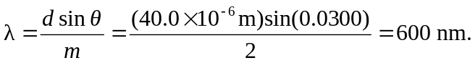
The velocity of an electron with this wavelength is given by Eq. 39.1
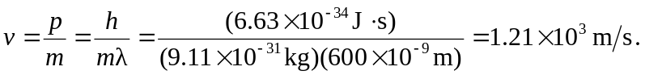
Since this velocity is much smaller than c we can calculate the energy of the electron classically

